- I am concerned about an observed upward shift in the reject rates that appears to have occurred between April 16th, 2012 (observation 12) and September 14th, 2012 (observation 13). I've plotted the rates by time, and they are shown below. It was not the gap of 5 months between these sequential observations that first concerned me (my concerns were first raised upon seeing the plot below), but I can't help but wonder if a fundamental change occurred between April and September, causing a process shift. I performed t-tests after splitting the data at the potential shift date, and the tests were significant for both foreign matter reject rate and overall reject rate (p < 0.001 for both) for the hypothesis of equal means between the groups. This does indicate that there is evidence to conclude the process mean before September 14th, 2012 is not the same as the process mean since this date.

The implication of a shift from a statistical perspective is that the estimates for mean and variance using the entire dataset are not in line with the current process mean and variance, so any intervals or limits based on the average and standard deviation may not be accurate. I would recommend investigating this shift.
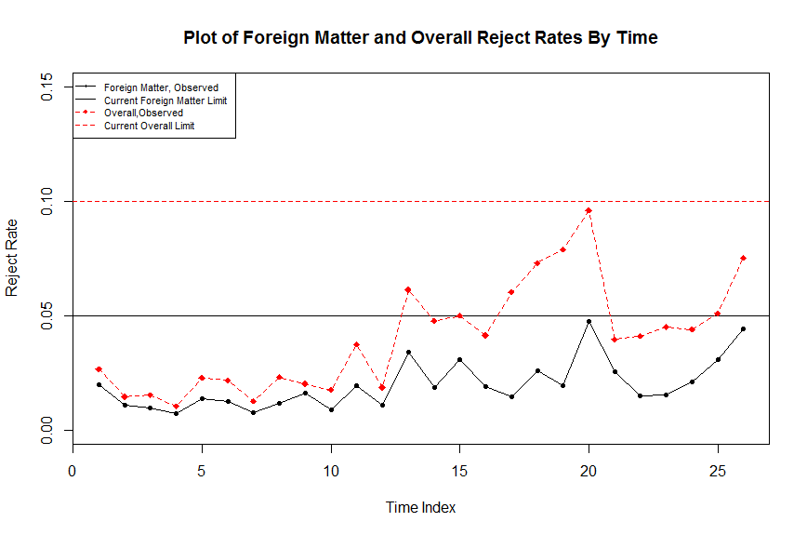
- There are some indications that there is a positive correlation between reject rate and lot size. However, the R² values from regressing reject rate (foreign matter and overall) vs. lot size are very small, so I'm very hesitant to say there is a true relationship. Most of the variance in reject rates is due to the last 14 lots, and since the lot size has been stable in that time frame I don't think this analysis is worth pursuing any further.

- From a statistical standpoint, the limit you are seeking is based on a tolerance interval, which is not the same as the commonly used confidence interval. The latter is used to report the level of precision we have regarding the process mean, in this case the proportion of rejected vials. However, I don't believe you are interested in putting a limit on the process average. Rather, you want a limit applicable to a reject rate for any given future lot, which is the goal of a tolerance interval. These intervals are wider than confidence intervals, since they take into account our imprecision of the process mean plus true process variability. I've proceeded with calculation of one-sided (upper) tolerance intervals. Tolerance intervals are reported with two percentages, unlike confidence intervals which are reported with one, e.g. 95% confidence interval. A 95%/95% upper tolerance limit means that with 95% confidence, 95% of future observations will be no more than the limit. As with confidence intervals, you can play with the percentage to get a number. I've taken the position to stick with 95% confidence, and have varied the second percentage so you can see how the limit changes.

- With a “large enough” sample size, the proportion of reject vials would indeed be normally distributed. The sample size in the dataset (n=26) is likely large enough to apply the normal theory for a tolerance interval. Two caveats though. First, the potential process shift described in point 1 makes the assumption of normally distributed data difficult to defend, since the normal theory requires a constant proportion, which I'm not sure exists in the timeframe for which the data was observed. Second, the variance of the reject rates is higher than one would expect if the normal theory held. The result is that the limits are higher than the theory would predict.

With all of that said, here are the upper tolerance limits using the entire dataset. All are given with 95% confidence.

Table: 95%/XX% Tolerance Intervals for Foreign Matter and Overall Reject Rates (n=26)
 | 90% Coverage | 95% Coverage | 99% Coverage
Foreign Matter Reject Rate | 0.0389 | 0.0437 | 0.0528
Overall Reject Rate | 0.0827 | 0.0931 | 0.1132

- Using only the last 14 observations, the following upper tolerance limits (with 95% confidence) are calculated. You can see that the 95%/95% tolerance limit gives you the current limits of 5% and 10%. The limits are higher since the average reject rates in this subset are higher than the average reject rates in the full dataset. The variances are similar between the subset and the full datasets (but still higher than theory would predict).

Table: 95%/XX% Tolerance Intervals for Foreign Matter and Overall Reject Rates (n=14)
 | 90% Coverage | 95% Coverage | 99% Coverage
Foreign Matter Reject Rate | 0.0479 | 0.0532 | 0.0633
Overall Reject Rate | 0.0940 | 0.1028 | 0.1196

